**Motor RN (Renewal Notice):**

Motor RN tables and package mentioned below

Table:

* Bjaj_mot_renewal_extn--------------------Motor Policy
* Bjaj_mot_renewal--------------------Motor Policy

Package:

Bjaz_pk_mot_rnw

Motor RN policy number we can see Renewal Notice Generation as mentioned below screenshot.

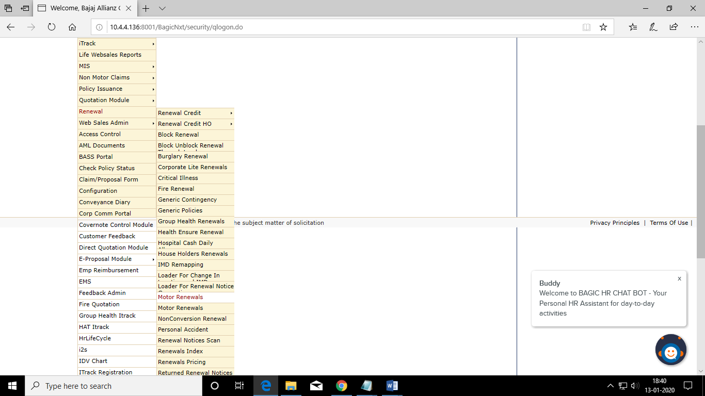

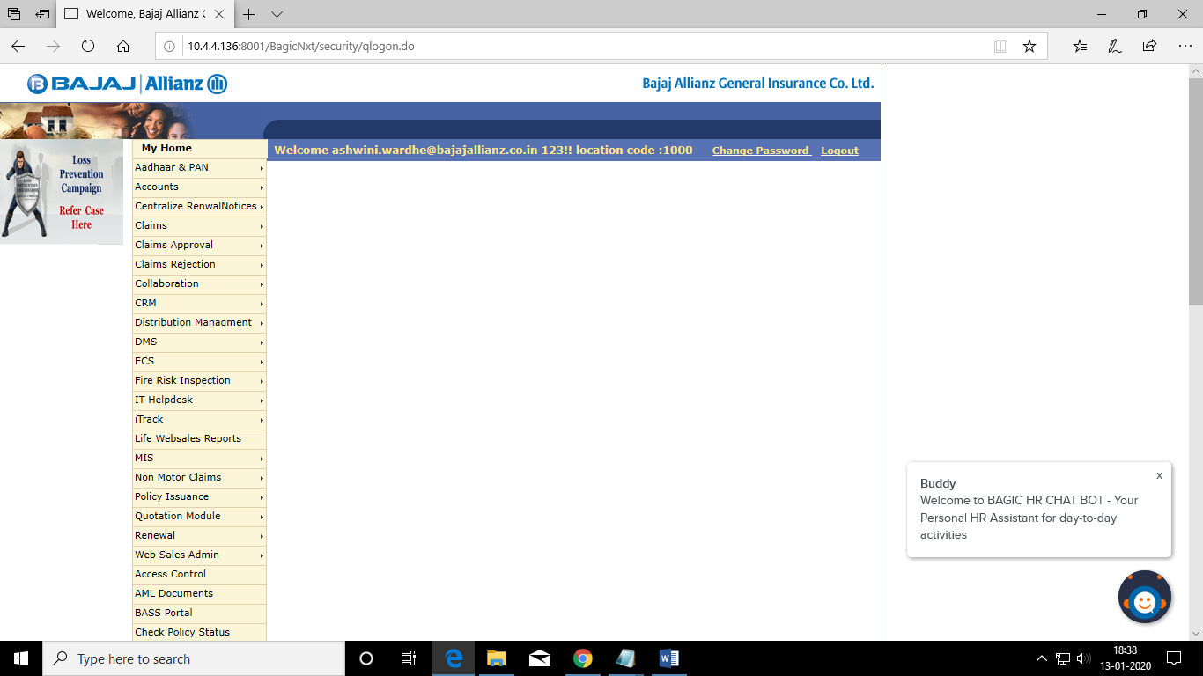

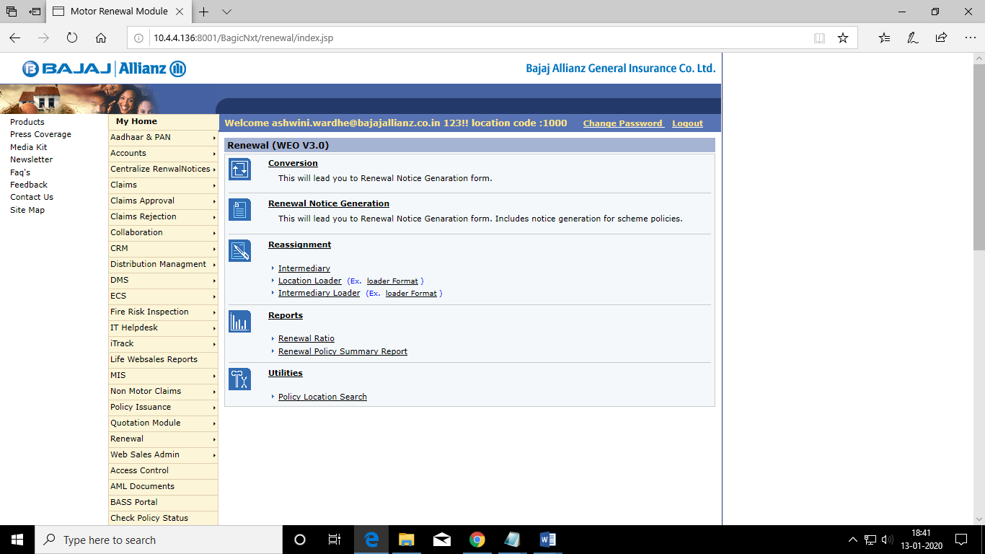

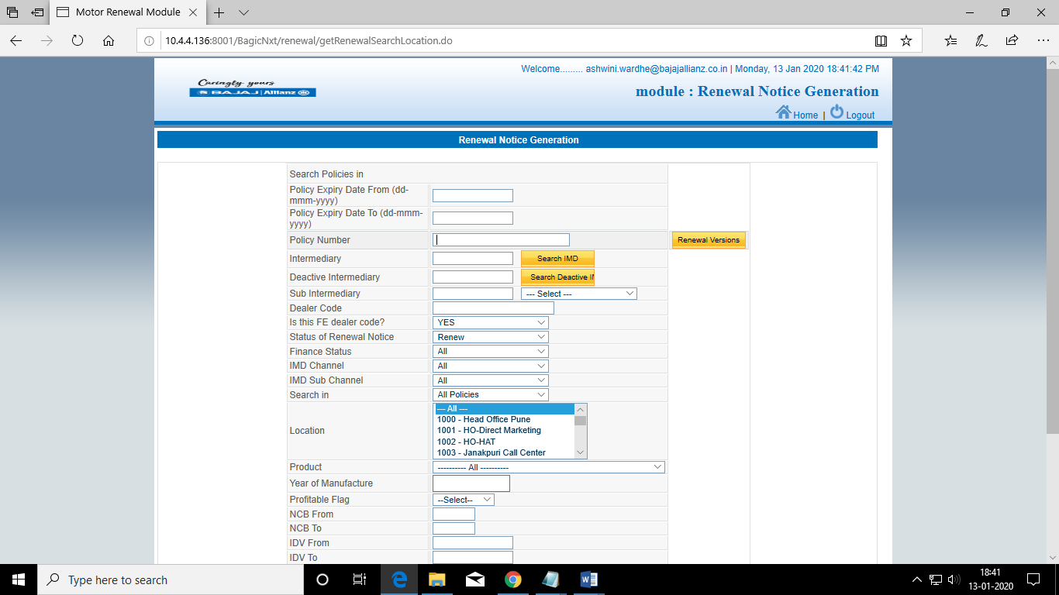

Clear Case database path for production package body extract into desktop.

